B22DCDT059 – Trần Anh Dũng
Ques1:
a.
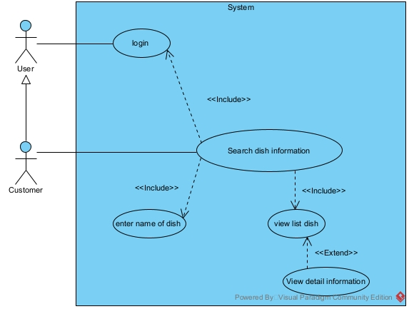
b.
Ques2:
a. Entity Extract
- User: username, password, fullName, role
- ManagementStaff
- SaleStaff
- WarehouseStaff
- Customer: address, phone
- Supplier: name, phone
- Table: name, capacity
- Invoice: date, totalPrice
- ImportInvoice: date, totalPrice
- ImportMaterial: amount, price
- Material: name, unit
- DishMaterial: description
- Dish: name, price, unit
- BookedDish: amount, price
- Combo: name, price
- BookedCombo: amount, price
- BookedTable: time
b.
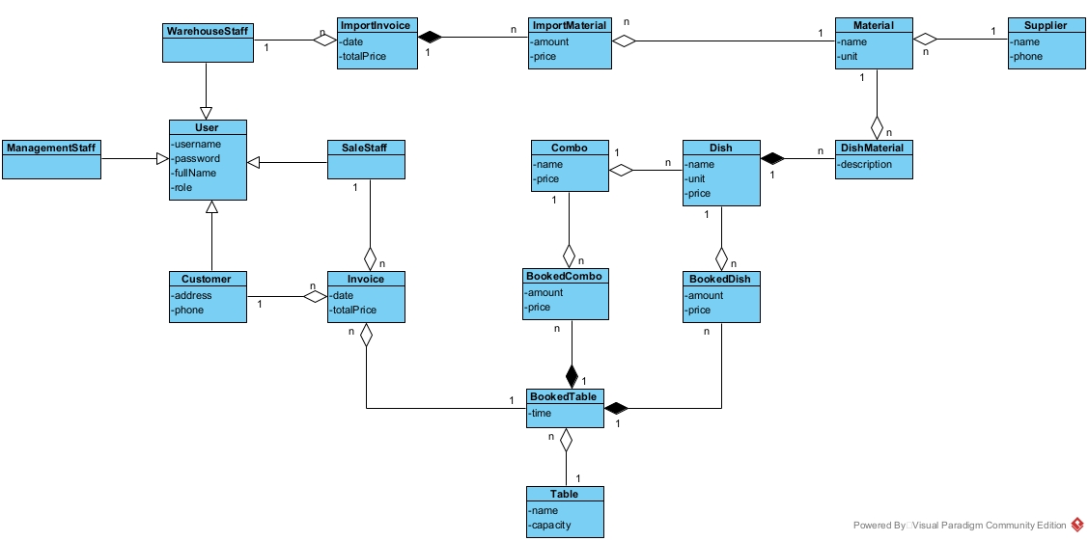
Ques3:
a.
b.
Ques4:
a.
b.

